Tisch Mux Room (TMR) Carrier Relocations to Kimmel North Technical Equipment Room (NTER)
Request for Proposal
Sept 10, 2018, 2018
Presented by:
NYU Langone Hospitals

Table of Contents

1. Objective 3
2. RFP Overview 3
3. Milestone Calendar 4
4. Proposal Due Date, Delivery Instruction and Communication 4
5. Proprietary Information, Non-Disclosure 5
6. Costs Incurred 5
7. NYULH Reserves Right to Reject Any and All Bids 5
8. Effective Period of Prices 5
9. Request for Proposal Scope 5
10. Pricing 10
11. Past Performance and References 11
12. Company Profile and Financial Stability 11
13. Methodologies 12
14. Work Experience 12
15. Evaluation Criteria 12
16. Enterprise Business Approach 13
17. Proposed Staffing Approach 14
18. High Level Timeline 14

Objective

NYU Langone Hospitals (NYULH) requests quotes in response to this Request for Proposals (RFP) as outlined and provided in detail in section (9) below.

RFP Overview

Introduction

The NYU Langone Hospitals (NYULH) including NYU Medical Center and NYU Hospital for Joint Diseases (NYUHJD) collectively referred to as “HOSPITALS”, invite you (the “SUPPLIER”) to submit a quote in accordance with the requirements, terms, and conditions in this Request for Proposal (RFP) for the “Tisch Mux Room (TMR) Carrier Relocations to Kimmel North Technical Equipment Room (NTER.)

This RFP process is your opportunity to demonstrate your strong commitment to partnering with HOSPITALS and ensures highly competitive pricing with quality customer support services.
This RFP solicits a detailed offering that includes line item pricing as well as a detailed response regarding your services, linen acquisition, initiatives and Contract/Payment Terms compliance. We encourage you to submit a Quote that is aggressively priced which will exceed our expectations and influence the consolidation of our SUPPLIERs and market share.
The RFP submissions will be applicable for NYU Langone Hospitals (NYULH) referred to as “Hospitals” having places of business at Tisch NYU Medical Center 550-560 First Avenue, New York, NY 10016 and NYU Hospital for Joint Disease 301 East 17th Street, New York, NY 10003 and Outpatient Surgery Center 333 E 38th Street (at 1st Avenue) New York, NY 10016.

Milestone Calendar

The following calendar of events is based on planned NYU Langone Hospitals (NYULH) activities and anticipated vendor delivery capabilities. It is presented for illustrative purposes only. These milestones will be reviewed as necessary at the time a contract is awarded to a vendor.
Milestones | Date | Time
RFP Release Date | 9/10/2018 | 5:00 PM EST
Intention to Bid | 9/17/2018 | 5:00 PM EST
Additional Question Due | 9/24/2018 | 12:00 PM EST
Answer to Vendors Due | 10/8/2018 | 12:00 PM EST
Initial Proposal Due | 10/26/2018 | 5:00 PM EST
Vendor Presentation | 10/31/2018 - 11/2/2018
Final Proposal Due | 11/5/2018 | 5:00 PM EST

Required RFP Response Format

Vendors are required to submit their Proposal in the specified electronic format. Vendor will submit their entire RFP response and all completed forms electronically via e-mail to NYULH with vendor’s information and responses provided in the appropriate places therein. The required electronic applications formats are Microsoft Word and Microsoft Excel. Any supporting graphic or presentation-based slides may be submitted in a separate PowerPoint file. PDF format is not acceptable for any submitted text, graphics or slides.

Proposal Due Date, Delivery Instruction and Communication

All Proposals are due by November 5th, 2018 no later than 5:00 P.M. EST
Send your complete electronic response via email to: ITSourcing@nyulangone.org

Bidders Note: All questions regarding interpretation or specifications must be submitted in writing to ITSourcing@nyulangone.org only. Under no circumstances shall vendor contact any employee of NYULH. Any dialogue initiated by the bidder not addressed to contacts above will result in an immediate disqualification. Discussions on other business matters and not related to this RFP are permitted.

Proprietary Information, Non-Disclosure

Vendor shall have no rights in this document or the information contained therein and shall not duplicate or disseminate said document or information outside the vendor's organization without the prior written consent of NYULH.

Costs Incurred

All costs incurred in the preparation and presentation of the Proposal shall be borne by vendor. By submitting a Proposal, vendor agrees that the rejection of any Proposal in whole or in part will not render NYULH liable for incurred costs and damages.

NYULH Reserves Right to Reject Any and All Bids

Nothing in this RFP shall create any binding obligation upon NYULH. Moreover, NYULH, at its sole discretion, reserves the right to reject any and all bids as well as the right not to award any contract under this bid process. NYULH reserves the right to award portion of this bid. All bids should be governed by NYULH standard Policy and Procedure and Terms and Conditions.

Effective Period of Prices

All pricing Proposals by vendor will remain fixed and firm until Oct 26, 2019.

Request for Proposal Scope

Description - NYU Langone Health (NYULH) is undertaking a Campus Transformation effort to the medical campus Superblock location bordering streets and avenues between First Ave & FDR Drive South and E30th & E34th Streets. This space is considered a Superblock by the U.S. Postal Service. (Picture 1.) The yellow “X” marks the general location of the TMR Carrier Relocation work. The red “X” marks the general location of the Berg Data Center.

The TMR is an older alternate Technology Equipment room that is mission-critical to a portion of the hospital's Voice, Data, PRI, SIP and POTs services.

Picture – 1

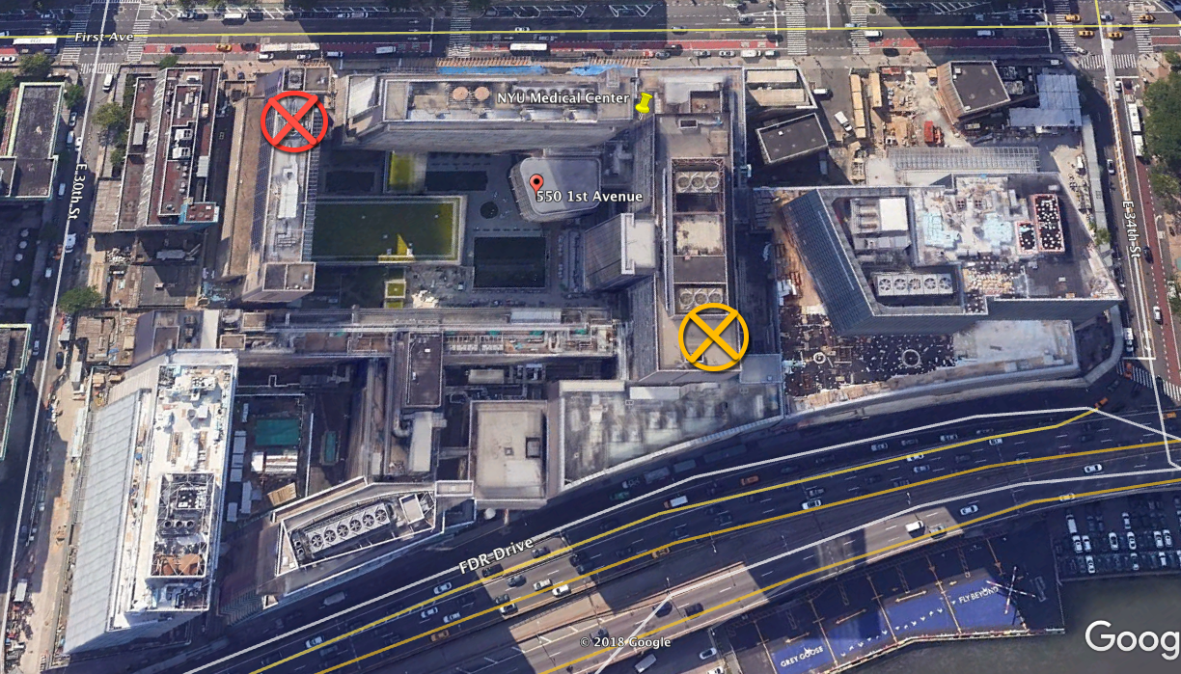

The chosen vendor will be asked to relocate all of the existing Telecom Carrier services, High Capacity (High Cap) feeders and approximately one hundred Point-to-Point (P2P) Ethernet circuits currently supporting Voice, Data services, PRI, SIP and POTs circuits located in the TMR to the Kimmel NTER.

Picture – 2 shows the location of the TMR on the Tisch Hospital Ground floor.
Picture – 3 shows a blow up of the contents inside the TMR room.

Picture – 2

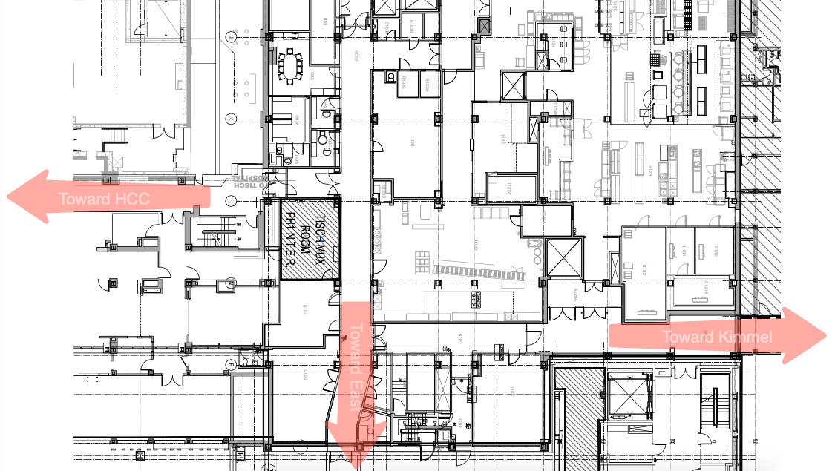

Picture – 3
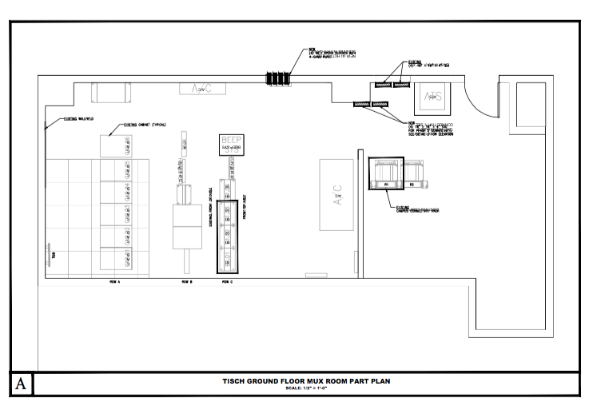

Actual Work Efforts Expected by the Selected RFP Vendor:
There are approximately (6) mission-critical Telecommunications providers (Needs to be confirmed by chosen RFP provider ) with a combined total of approximately one hundred circuits supporting Voice and Data services including those provided via NYULH Owned dark Fiber services from inside the TMR.
The following services enter the TMR space.
- NYU-owned 300 Pair Cat-3 Copper Services
- Spectrum – High Cap Fiber
- Verizon – High Cap Fiber
- RCN – High Cap Fiber
- Lightower (now Crown Castle) -
- Windstream
- NYULMC owned Dark Fiber service.

Phase 0 – Documentation Gathering and verification.
Starting approximately December 1, 2018, the selected vendor (SELECTED VENDOR) for this project will verify the “Kick-off” inventory of all P2P circuits with each of the carrier vendors inside the TMR. The Kick-off circuit database must be verified by the SELECTED VENDOR for each P2P circuit on this list. Items found to be missing off the list will be added by the SELECTED VENDOR to the list and to the NYULH Circuit Repository (NCR). The SELECTED VENDOR will contact each carrier's dedicated Customer Service team that supports the NYULH accounts. Much work needs to be accomplished as early as possible to assure the accuracy of each P2P leased circuit included within the High-Cap Service Conduit system.

- Accuracy of the near end port location inside the BDC
- Accuracy of the far end termination point – Building Address and Floor.
- Account Number
- Vendor
- Circuit ID
- Billing Contact
- Pending Balances due
- Circuit Term or remaining term
- Cancelled Services (No longer being used, remote medical site is close)
- Closed Accounts (Has previously been cancelled, equipment can be eliminated)

NYULH desires to order all new individual circuits from end to end. This involves highly coordinated circuit conversions (Lift and Lay) methods including a 3 to 5 day burn-in period before any new circuits is considered production and put into Layer (3) routing.

All old circuits will be cancelled by placing orders with the 5 vendor groups included in the original conduits.

Please Note: Vendors responding to this bid may offer other suggested methods to avoid touching the Far-End equipment, allowing it to remain the same (often referred to as “Hot-Cuts”). Based on the responding vendors' experience and plan, NYULH Telecom may consider using hot-cuts as another method to compress the schedule and to allow for quicker burn-in period. Hot-Cuts will only be possible if the location in question has a viable “Stable” back-up circuit of a similar size, speed and latency.

The SELECTED VENDOR will work with the NYULMC Telecom and NetOps teams to verify and map all the in-service (production) NUYLMC internal owned vertical and horizontal Dark Fiber Services inside the TMR for the purpose of its migration of those services using the TRM fibers away from TRM and over to the new Kimmel NTER.

Note: NYULMC may at the time of this awarded RFP have another project underway called the “B” Shaft Circuit Relocation. That project also involves the same type of Carrier Circuit relocations. At no time will the TMR relocation circuits and the “B” Shaft circuits to the same remote location be out of service at the same time. No one location can go dark as a result of Primary and Back-up circuits to the same location being down. Careful planning is mandatory to prevent such an occurrence if both project are in flight at the same time. The SELECTED VENDOR of this RFP will coordinate with the SELECTED VENDOR of the awarded vendor of the “B” Shaft Circuit Relocation.

Phase 1 – (Database and Requirements Preparation)
The SELECTED VENDOR will segment the known, accurate circuits into vendor move packages matching the criteria listed below. The SELECTED VENDOR will contact each circuit vendor for the purposes of planning the method of conversion. We need to understand conversion methods, equipment necessary to complete the project, costs and schedule dates.

These are the criteria goals in conversations with each vendor:
- Lowest cost
- Lowest risk
- Shortest time span to complete
- Lowest impact to our remote locations
- Zero Early Termination Liability

Once the established conversion method is decided, the SELECTED VENDOR will issue the circuit work-orders pertaining to best method chosen for the circuit conversion to the Telecommunications Director for final signature. The SELECTED VENDOR will track and control the work order pertaining to this effort in a secure database that is backed-up on a secure server. NYULH may choose to provide the SELECTED VENDOR with a secure separate area within our NCR, but that decision is not promised and will be decided later.

Phase 2 thru X – (Circuit Conversions to NTER)

Final Phase – (Project Close-out)
The SELECTED VENDOR will close-out all project activities, ensuring that all unused circuits are cancelled and billing is purified for those circuits no longer needed and that all the new circuits are added to the NYULH Circuit Repository. NYULH Circuit Repository records must be reviewed for accuracy before the SELECTED VENDOR leaves the original project.

SELECTED VENDOR Qualifications –
- Has worked on a similar large circuit related project.
- Has moved a very large building of100 to 200 plus P2P circuits from one location to another.
- Has worked directly with most of the vendors listed
- Understands how to place orders, escalate, monitor, track, etc.
- Can demonstrate strong project management certification and examples from other past projects
- Has at least one member with 10+ years of technical experience in the area of Ethernet equipment, Telecommunications, and Point to Point Voice and Data circuits.
- Has individuals with CCNA certification able to work with our NYULH NetOps team for the purposes of circuit turn-up and conversions.
- Has finance individuals able to keep track of billing, credits, cancellations and activations of all that has to do with P2P activity
- Has own transportation and is able to be available at all remote locations as expected.
- Can execute multiple conversions at one time
- Is able to work into late evenings and weekends
- Can establish and manage a Circuit Helpdesk for all cutovers though project completion.

Payment –
Payment methods will be broken into milestone phases. Only at the completion of a full milestone will the SELECTED VENDOR be able to bill out that full phase.

Pricing

- Utilizing the attached worksheet provide a detailed price estimate by phase or sub-project, including a summary of all costs and a detailed list of each item proposed and its associated cost. Please distinguish each proposed cost into categories, for example: consulting, training, travel, etc.

Past Performance and References

Please provide a list of three academic hospitals, Legal or Financial Institutions who have received services on similar engagements as the one outlined by this RFP and include the information below.
- Client name and headquarter address
- Contact name
- Telephone number
- Email address
- Length of time using your services
- Brief description of the service provided
Failure to provide suitable references to NYULH will result in the vendor’s bid being rejected without further consideration.

Company Profile and Financial Stability

Please provide information that will enable us to evaluate your company’s financial stability. We require that you include the following:
- Company description: including ownership, number of years in business, strategic direction, mission, history, acknowledgements or awards
- Recent financial results
- Partner relationships
- Description of selection criteria for contractor or co-implementation partners
- Work force distribution by country, city, state, etc.
- Total number of employees: include number of project managers, implementation specialists, development engineers, % full time versus contracted, etc.
- Average number of years of application and implementation experience and business process definition for consultants and managers

Methodologies

Please provide information that will enable us to evaluate your company’s processes and controls. We require that you include the following:
- Provide a detailed overview of the company’s project management methodologies including documentation deliverables
- Please provide a description of the company’s quality control procedures
- Provide a list of the criteria the company uses to determine project success

Work Experience

Please provide information that will enable us to evaluate your company’s track record and capabilities. We require that you include the following:
- Brief description of a complex implementation project including: client name, applications implemented, phase approach and duration
- Description of the solution environment
- Design and/or implementation artifacts
- Business Process design and re-engineering artifacts
- Provide a count of designs and/or implementations completed by members of your team in the healthcare Legal or Financial Institutions over the past three years
- Detailed description of the most complex design and/or implementation at a customer site
Provide detailed description of value added services that differentiate your company from your competitors.

Evaluation Criteria
Evaluation Criteria
Section 1 - Experience

Section 2 - Help Desk and Scheduling

Section 3 – Hands On Experience with Cisco Networking and Cisco Call Manager

Section 4 – Strength with Telecommunications Vendors

Section 5 – Price competitiveness/Potential Cost Reductions

Section 6 – MSA Review

Proposed Staffing Approach

- Provide an outline of a proposed staffing for this engagement and include the below information.
  - Reporting relationships
  - Resource skill set
  - Project role and responsibility
  - Suggested work location
  - Named assignments and resumes
  - Number of years of experience relevant to this project
  - Indicate the engagements in which the team member participated and their role
  - Standard hourly rate

- NYU reserves the right to refuse proposed staff.

High Level Timeline
- Provide a high level strategy or approach for the project as defined in this RFP, include milestones, phase deliverables and integration points between requirements. Include a high level timeline based on this approach.

