Access Booking Software Engineering Team

NYU Langone Health
September 6th, 2018
Presented by:
NYU Langone Health

Table of Contents
1. Introduction 4
2. Milestone Calendar 4
3. Required RFP Response 5
4. Proposal Due Date, Delivery Instructions and Communication 5
5. Proprietary Information, Non-Disclosure 5
6. Costs Incurred 5
7. NYULH Reserves Right to Refuse Any and All Bids 6
8. Effective Period of Prices 6
9. Requirements 6
10. Pricing & Cost 16
11. Description of Company 17
12. Past Performance and References 17
13. Evaluation Criteria 18

Introduction

The NYU Langone Hospitals (NYULH) including NYU Medical Center and NYU Hospital for Joint Diseases (NYUHJD) collectively referred to as “HOSPITALS”, invite you (the “SUPPLIER”) to submit a quote in accordance with the requirements, terms, and conditions in this Request for Proposal (RFP) for Access Booking Software Engineering Team.
This RFP process is your opportunity to demonstrate your strong commitment to collaborating with HOSPITALS and ensures highly competitive pricing with quality customer support services.
This RFP solicits a detailed offering that includes line item pricing as well as a detailed response regarding your services, linen acquisition, initiatives and Contract/Payment Terms compliance. We encourage you to submit a Quote that is aggressively priced which will exceed our expectations and influence the consolidation of our SUPPLIERs and market share.
The RFP submissions will be applicable for NYU Langone Hospitals (NYULH) referred to as “Hospitals” having places of business at Tisch NYU Medical Center 550-560 First Avenue, New York, NY 10016 and NYU Hospital for Joint Disease 301 East 17th Street, New York, NY 10003 and Outpatient Surgery Center 333 E 38th Street (at 1st Avenue) New York, NY 10016.

Milestone Calendar

The following calendar of events is based on planned NYULH activities and anticipated supplier delivery capabilities.

Milestones | Date | Time
Release RFP | 9/10/18 | 5:00 PM
Vendor Questions Due | 9/19/18 | 5:00 PM
Responses to Vendor Questions Due | 9/20/18 | 5:00 PM
Responses to RFP Due | 9/28/18 | 5:00 PM
RFP Presentations (webex) | 9/29/18-10/15/18

Required RFP Response

Suppliers are required to submit their Proposal in the specified electronic format. Supplier will submit their entire RFP response and all completed forms electronically via e-mail to NYULH with supplier’s information and responses provided in the appropriate places therein. The required electronic applications formats are Microsoft Word and Microsoft Excel. Any supporting graphic or presentation-based slides may be submitted in a separate PowerPoint file. PDF format is not acceptable for any submitted text, graphics or slides.

Proposal Due Date, Delivery Instructions and Communication

All Proposals are due by 9/28/2018 no later than 5:00 P.M. EST

Please send your complete electronic response via email to ITSourcing@nyulangone.org

Bidders Note: All questions regarding interpretation or specifications must be submitted in writing to ITSourcing@nyulangone.org only. Under no circumstances must supplier contact any employee of NYULH. Any dialogue initiated by the bidder not addressed to contacts above will result in an immediate disqualification. Discussions on other business matters not related to this RFP are permitted.

Proprietary Information, Non-Disclosure

Supplier must have no rights in this document or the information contained therein and must not duplicate or disseminate said document or information outside the supplier's organization without the prior written consent of NYULH.

Costs Incurred

All costs incurred in the preparation of the Proposal must be borne by supplier. By submitting a Proposal, supplier agrees that the rejection of any proposal in whole or in part will not render NYULH liable for incurred costs and damages.

NYULH Reserves Right to Refuse Any and All Bids

Nothing in this RFP must create any binding obligation upon NYULH. Moreover, NYULH, at its sole discretion, reserves the right to reject any and all bids as well as the right not to award any contract under this bid process. NYULH reserves the right to award portion of this bid. NYULH reserves the right to adjust the evaluation criteria after finalizing the scope and pricing requirements after the supplier demo meeting. All bids should be governed by NYULH standard Policy and Procedure and Terms and Conditions.

Effective Period of Prices

All pricing Proposals by supplier will remain fixed and firm through December 31, 2019.

Requirements

All questions need to be answered in this RFP document.

Introduction

The NYU Langone Health is an integrated academic medical center integrating clinical care, academic instruction and clinical research activities. Through this integration we are able to provide world class medical care to the general population as well as support academic and research efforts to advance health care into the future.

As part of a larger effort to inform and connect to the general public about our mission and organization, the NYUMC maintains a large web site and mobile application. Through these digital tools patients are able to access information and arrange for health care services. These services include access to their electronic medical records, appointment booking and communication with their care team.

As part of our ongoing efforts to enhance and support these web properties, NYUMC is seeking to partner with a firm (or firms) to provide outsourced technical capabilities for the further development, maintenance and support of these digital properties.

The appointment booking digital properties in scope for this RFP are as follows:

- The Find A Doctor & Online Scheduling web application that allows patients to search for providers on our public web site and in our mobile application.
- The Virtual Urgent Care web application that allows new patients to schedule virtual urgent care appointments.
- The Radiology Appointment Booking application that allows patients with radiology orders to book these appointments through the mobile application.

The following sections describe in more detail the technical requirements for the development work associated with these digital tools.

Team Roles and Duties

The following describes the roles/functions that would need to be provided by the teams for our organization.

Function | # Roles | Experience (Years) | Description
Senior Technical Liaison | .25 (PT) | 10+ | A senior technical liaison within the firm to ensure that the development work is aligned with the architectural and organizational goals and standards.
Lead Software Development | 1 | 10+ | Provide senior support for the software engineers and efforts are aligned with goals of the platform and NYUMC. Note: The Lead Developer will be responsible for working with an NYUMC Architect and/or Onsite NYUMC Technical Liaison.
Software Development | 3-6 | 5+ | Write the source code implementing features as requested by NYUMC staff, writing unit tests for all source code and instrumenting applications for operational metrics gathering.
Quality Assurance | 1-2 | 5+ | Create and execute on a strategy to assure delivery of high quality software releases. This includes the ability to create automated tests as necessary.
Business Account Management | .25 (PT) | 5+ | Someone dedicated to managing the business relationship with NYUMC.
Delivery | .5 | 5+ | Ensuring the right features are being developed, helping to remove impediments and reporting on the status of the development efforts.
Business Analyst | 1 | 5+ | (Optional) On site analyst to document user stories and requirements.
UX / Design | 1 | 3+ | (Optional) On site designer to provided graphics to the team as needed.

Supplier Answer: Indicate how the team would be staffed to provide these functions to the NYUMC organization in the service of our digital product(s). Also please indicate the recommendations for locating these resources (onsite or offsite/offshore).

Notes:
- You will be asked to provide pricing for various offshore/onshore configurations below in the pricing section.

Technology Overview & Requirements

The diagram & sections below illustrates the logical architecture of the appointment booking applications.

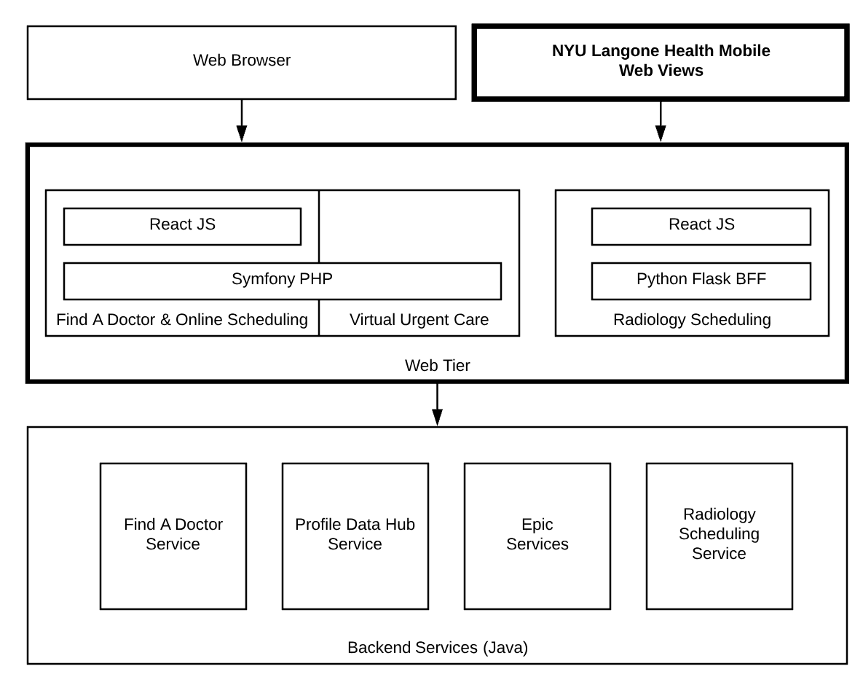
The applications in scope are in the “Web Tier” and also the “NYU Langone Health Mobile App”.

Web Applications

There are three web applications in scope for this RFP. The web applications are listed in the “Web Tier” in the diagram above. These web applications handle the rendering of a UI that is served directly to users on desktops using web browsers and also into the NYU Langone Health Mobile application using web views (see below).

- The Find A Doctor application is a Symfony PHP based application that utilized React.JS to handle user interactions. This application integrates with backend java services for the Find A Doctor search queries and booking of of appointments into the Epic HER.
- The Virtual Urgent Care booking application also lives within a shared Symfony code base and provides functionality for patients to book Virtual Urgent Care appointments that are fulfilled in MyChart and in the mobile application.

- The Radiology Booking is built in Python Flask MVC with a React.JS rendered UI. This application also integrates through backend java services to provide appointment booking times and actual scheduling of radiology appointments in the Epic EHR.

The following is a list of the technologies used in the Web applications
Technologies | Description
Scripting Languages | PHP 5.x, Javascript, Typscript, Python
Frameworks | Symfony PHP 2.x, REACT.JS, Python Flask
Testing | PHP Unit, Cucumber, Selenium
Systems | Red Hat Linux / CentOS
Management Tools | Atlassian Jira/Confluence
Devops | Docker, Ansible, Jenkins
Caching | Varnish, Reddis
Version Control | GIT / Atlassian Stash/Bitbucket
Monitoring | Nagios, Graphite, Grafana, ELK

Mobile AppMobile application

The mobile app is a custom iOS & Android application that uses an SDK from Epic Systems to integrate with the Epic EHR and provide scheduling functionality. In addition it has the following integrations:

- Wayfinding functionality is provided through Phunware systems SDK.
- Find A Doctor, Radiology Booking and Virtual Urgent Care booking are provided in the mobile experience through web views in the mobile application.

For these web views the user is authenticated into a session on the web site via an Oauth handshake.

The following is a list of technologies and languages used to create and manage the mobile platform.
Technologies | Description
Programming Languages | Swift (iOS), Kotlin (Android)
SDK | Phunware, Epic MyChart
Testing | Appium
Management Tools | Atlassian Jira/Confluence
Devops | Jenkins
Version Control | GIT / Atlassian Stash/Bitbucket
Monitoring | Crashlytics

Note: Chosen vendor will need to enter into an agreement with Epic software (through their App Orchard program) prior to working with the MyChart SDK.

Supplier Answer: Indicate your company’s expertise with each of these technologies, including:

- Profiles of employees who have worked with these technologies and who would be eligible to work on our team. Please include years of experience and examples of past projects with the details of the technologies used on the projects.

- Number of employees that work with these technologies within the organization

Engineering Discipline & Practices

As the public will increasingly obtain our services through digital tools, the quality of the software we develop and support will be exponentially important. Good software engineering practices have proven to significantly enhance the value of delivered software to an organization in terms of the efficiency with which it can reliably introduce new features.

Supplier Answer: Please describe following as it relates to software engineering practices within your organization:

- What are the key practices and methodologies your organization believes are necessary to ensure high quality deliverables?
- Who are the industry thought leaders that best inform your companies strategies for ensuring the highest quality software deliverables?
- Who in your organization is responsible for providing the strategic vision for cultivating high quality software development in your company?
- How does your company audit/ensure that quality software development practices are followed for all client work?
- List at least 3 books that you encourage software engineers to read or that you use as training materials.

Experience in Problem Domains

The selected firm will ideally provide a team that has experience in the architectural and technical problem domains for this project.

The problem domains for the product are as follows:

- Building intricate user experiences in front end web application engineering tools using React JS

- Building native iOS and Android applications

- Expertise in effectively testing mission critical applications to minimize the incidence of customer impacting bugs in production.

- Integrating external services into an application and managing the inherent risks of service failure.

- Employing development, testing and release strategies that facilitate rapid change while ensuring stability of the product.

- Ensuring that the software being created can be effectively supported in production.

- Managing technical risk as it relates to scope and hard deadlines.

- Working in a regulated environment & creating secure software solutions

- Working with Health care organizations and familiarity security around PHI, with content around types of care, conditions, treatments, etc.

Supplier Answer: Please describe your firm’s experience in these problem domains and strategies for solving them. Please refer to your experience with other large projects as appropriate.

Project Management and Communication

Inefficient communication and process can lead to lost time and wasted effort when undertaking complex technical projects.

Supplier Answer: Please provide the following information as it relates to Project Management and Communication

- Describe your preferred project management methodologies and strategies for ensuring communication structures that minimize waste in the development process within co-located and for remotely located teams.

- Describe how you demonstrate the value & efficiency delivered by the software development teams.

- Describe how you evaluate the performance of the team.

Operational Support

In conjunction with the internal systems and networking operations teams, the software engineering team developing the profiles application will also be responsible for supporting the operations of the application after it goes into production. The support level requested is Level 3 on a 24x7 basis with the following SLAs.

Severity | Description | Business Impact | SLA
1 | Site Down/Unresponsive | Critical | 30 Minutes 1st response, Work until services are restored as needed.
2 | Site is partially impacted – users can complete work with visual defects, some functions may not work | Significant | 1 hour to 1st response time, work until services are restored or triaged
3 | Non-essential features are impacted | Normal/Average | 6 hours to 1st response, completed next business day
4 | Minor display or non-functional issue | Low | Next business Day

In addition, the engineering team engaged for this project will be responsible for helping to configure and manage monitoring and alerting tools necessary for operational support.

Supplier Answer: Describe how your team will be organized to provide 24x7 support for this application in terms or rotation, software, etc.

Security

As a healthcare organization security is extremely important to protect the private health information of our patients. Although your firm would not have access to PHI (viewing, storing or transmitting) it is important that our partners have appropriate security controls in place to reduce the risk of unauthorized access to any of our systems and/or intellectual property.

Supplier Answer: Describe the security policies, controls, staffing and infrastructure your firm deploys to ensure the security of our systems and intellectual property.

Pricing & Cost

NYUMC wishes to engage the team of engineers on a time and materials basis with the team executing on tasks delegated to them through a prioritized backlog of work maintained by NYUMC.

Supplier Answer: As an additional data point to the staffing model provided as an answer to section 9.2, provide monthly and annual run rate for each team (public web and backend services) including itemized costs of each team member and the number of hours they will work on the product per week.

Also please include:

- Pricing for various location options (offshore, nearshore, onshore, onsite including different country options).
- Preferences for travel an associated costs.

Talent Cultivation and Team Building

The ability of a partner firm to recruit, cultivate and retain engineering talent will have a very significant impact on the ability of the partner firm to continuously support the production of high quality software for NYU Langone Health digital products.

Supplier Answer: In this regard, please describe the following aspects of this topic:

- What is your recruiting strategy?
- What is your retention strategy?
- What is the attrition rate at your organization?
- What is the attrition rate of your software developers?
- How are software engineers groomed for more responsibility in your organization?

Description of Company

All questions need to be answered in this RFP document.

Please provide:

- The company’s full name, address, main telephone and appropriate contact information including e-mail address.
- A brief historical perspective on your company (years in the business, growth via mergers and acquisitions, key industry innovations)
- What are your company values?
- Describe your corporate culture. Explain how you differentiate yourself from your competition.
- List office locations and specific responsibilities of each area.
- Please provide an overview of your company’s growth over the past five years.
- Provide audited financial statement for the two fiscal years immediately prior to this one.
- What percentage of your business is in healthcare?

Past Performance and References

Provide at least three (3) references of engagements on projects with a similar technical and architectural profile as this project.

For each reference, please include the following:
- Organization name, contact name, title, address and telephone number.
- Describe the relationship and services provided.
- If you cannot provide at least one healthcare reference of a similar size and scope of NYULH, please explain and indicate the largest installation you have performed.
- Provide current and past account information, of similar size and configuration. Include:
  - A current, long-term customer
  - A current customer implemented in the past 18 months
  - A former customer terminated within the past 18 months and reasoning for termination other than consolidation

Failure to provide suitable references to NYULH will result in the Supplier’s bid being rejected without further consideration.

Evaluation Criteria

NYULH plans to evaluate the supplier’s response based on the following criteria:

- Knowledge of Technologies
- Experience in Problem Domains
- Software Engineering Discipline and Practices
- Project Management and Communication
- Talent, Team Building and Retention Strategy
- Healthcare experience
- Past Performance and References
- Operational Support
- Security
- Pricing and Cost

