Kimmel Pavilion and Science Building Telephone Deployment Project
Request for Proposal
April 7, 2017
Presented by:
NYU Hospitals Center

Table of Contents
1. Introduction 3
2. RFP Activities Calendar 4
3. Required RFP Response 4
4. Proposal Due Date, Delivery Instructions and Communication 4
5. Proprietary Information, Non-Disclosure 4
6. Costs Incurred 5
7. NYUHC Reserves Right to Refuse Any and All Bids 5
8. Effective Period of Prices 5
9. Requirements 5
10. Scope of Work 6
11. Just-In-Time Telephone Staging and Deployment Assistance 11
12. Potential Additional Scope of Work - Science Building 11
13. Professional Services and Customer Support 12
14. Pricing 12
15. Description of Company 13
16. Past Performance and References 13
17. SUPPLIER Contract Terms and Master Services Agreement 14
18. Evaluation Criteria 14

Introduction

The NYU Hospitals Center (NYUHC) including NYU Langone Medical Center and NYU Hospital for Joint Diseases (NYUHJD) collectively referred to herein as “HOSPITALS”, invite you (the “SUPPLIER”) to submit a quote in accordance with the requirements, terms, and conditions in this Request for Proposal (RFP) for a qualified professional Telecommunications vendor to stage and deploy Cisco VoIP telephones on NYU’s existing VoIP network.

The HOSPITALS is in the process of constructing the new Kimmel Pavilion that will be located on the NYU Hospitals Center (NYUHC)’s main campus, 424 E 34th St. This building is scheduled to open in the 2nd quarter of 2018 with 21 floors and will function as a world-class medical facility offering the latest in technology and a comprehensive range of health care services.

This RFP solicits bids from SUPPLIERS who can fulfill the HOSPITALS' requirements to efficiently stage and subsequently deploy and test Cisco IP telephones (8800 and 7800 series phones) and analog telephony devices (test only) in the Kimmel Pavilion. The scope of the project involves approximately 1,950 Cisco IP telephones and approximately 855 associated telephone accessories (expansion modules). The scope of work also includes preparation of Cisco telephony equipment for each deployment phase; to include scanning each Cisco telephone box MAC address and labeling each box with (full name, full telephone number and room number). This pre-deployment staging work will be done at the off-site Kimmel Pavilion Warehouse located in Newtown, Connecticut. The SUPPLIER will also be required to audit Cisco equipment moved from the warehouse to the Kimmel Pavilion for each deployment phase prior to SUPPLIER'S equipment deployment on the respective floors in Kimmel.

We generally believe that this project will be comprised of five distinct phases in both the warehouse and at the Kimmel location. Based upon the projected total quantities of IP phones and accessories (expansion modules), SUPPLIERS should consider that a phase will involve 390 IP telephones and 171 expansion modules. We currently expect that the warehouse staging work will start in early November 2017 and be completed sometime in early December. We currently expect that deployment phases at Kimmel will start in January 2018 for the Day-in-the-Life and the entire installation will be completed in May 2018. Please carefully note that these dates are subject to change.

This RFP process is your opportunity to demonstrate your strong commitment to collaborating with HOSPITALS and to provide highly competitive pricing along with a commitment to high quality customer support services.

This RFP solicits a detailed offering to include line item pricing as well as a detailed response regarding your proposed services and your stated compliance with the requested scope of work. We encourage you to submit a bid that is aggressively priced.

RFP Activities Calendar

The following calendar of events for this RFP process is based on planned NYUHC activities.

RFP Process Milestones | Date | Time
RFP Release Date | April 7, 2017
Intention to bid | April 17, 2017 | 5:00 PM EST
Vendor Question due | April 24, 2017 | 5:00 PM EST
NYUHC Answers to Vendors due | April 28, 2017 | 5:00 PM EST
Proposals Due | May 12, 2017 | 5:00 PM EST

Required RFP Response

SUPPLIERS are required to submit their Proposal in the specified electronic format. SUPPLIER will submit their entire RFP response and all completed forms electronically via e-mail to NYUHC with SUPPLIER'S information and responses provided in the appropriate places therein. The required electronic applications formats are Microsoft Word and Microsoft Excel. Any supporting graphic or presentation-based slides may be submitted in a separate PowerPoint file.

Proposal Due Date, Delivery Instructions and Communication

All Proposals are due by May 12, 2017, no later than 5:00 P.M. EST

Please send your complete electronic response via email to ITSourcing@nyumc.org

Bidders Note: All questions regarding interpretation or specifications must be submitted in writing to ITSourcing@nyumc.org only. Under no circumstances must SUPPLIER contact any employee of NYUHC other than as defined above. Any dialogue initiated by the SUPPLIER not addressed to the IT Sourcing e-mail address above will result in an immediate disqualification. Discussions on other business matters not related to this RFP are permitted.

Proprietary Information, Non-Disclosure

SUPPLIER has no rights in this document or the information contained therein and must not duplicate or disseminate said document or information outside the SUPPLIER's organization without the prior written consent of NYUHC.

Costs Incurred

All costs incurred in the preparation of the Proposal must be borne by SUPPLIER. By submitting a Proposal, SUPPLIER agrees that the rejection of any proposal in whole or in part will not render NYUHC liable for incurred costs and damages.

NYUHC Reserves Right to Refuse Any and All Bids

Nothing in this RFP creates any binding obligation upon NYUHC. Moreover, NYUHC, at its sole discretion, reserves the right to reject any and all bids, as well as the right not to award any contract under this bid process. NYUHC also reserves the right to award only portions of the scope of work defined within this RFP. All bids will be governed by NYUHC standard Policy and Procedure and Terms and Conditions.

Effective Period of Prices

All pricing submitted by SUPPLIER in response to this RFP will remain fixed and firm through May 31, 2022.

Requirements

- SUPPLIER must have experience in deployments of similar scope and size with the exact hardware contained in this RFP.
- Selected SUPPLIER must have the appropriate team members report to a designated location within the Kimmel Pavilion one hour prior to the scheduled start time for each deployment phase.
- Proposed install services must include a lead technician who will work with the NYUHC Telecom project manager to attend meetings prior to the scheduled staging and deployment phases. It is expected that these planning meetings will require 8 hours per phase for both the staging and deployment scope of work thus 40 hours for staging and 40 hours for deployment.
- SUPPLIER will have a primary Telecom lead technician and a secondary lead technician or the entire project.
- Please Note: SUPPLIER's actual warehouse staging and Kimmel deployment schedules may vary depending upon the construction progress of the new Kimmel Pavilion. NYUHC will work to provide a 2-week e-mail notice of a schedule change and no additional charges will apply from the SUPPLIER.
- If the SUPPLIER is unavoidably delayed at any time in the progress of the work by any act or neglect of NYUHC or consultant engaged by NYUHC, or by any employee or agent of either, or by any separate contractor hired directly or indirectly by NYUHC, or by changes ordered in the work, or by labor disputes, fire, unusual delay in transportation, adverse weather conditions not reasonably anticipatable, unavoidable casualties or any other causes beyond the reasonable control of the SUPPLIER or a contractor to the SUPPLIER, or by delay authorized by NYUHC, then the Contract Time shall be extended by Change Order for such time as work is necessarily delayed by such cause as the SUPPLIER’s sole remedy.

- SUPPLIERS must provide specific responses to each bullet above within this section that indicates their full understanding of and compliance with each requirement listed.

Scope of Work

GENERAL PROJECT OVERVIEW
- NYUHC will provide a designated work area within the Kimmel Pavilion Warehouse equipped with computers and phones and this staging area will be on the NYUHC network.
- SUPPLIER shall be responsible for staging and testing all Cisco phones (8800 and 7800 series) and all expansion modules.
- SUPPLIER shall be responsible for coordinating all Cisco phone equipment moves from the Kimmel Pavilion Warehouse to the Kimmel Pavilion for each deployment phase.
- SUPPLIER shall be responsible for assembling, installing, and testing all Cisco devices at Kimmel.
- SUPPLIER shall be responsible for placing red emergency stickers on phones, placing desk drop materials (including training materials), and any other peripherals at the desktop.
- SUPPLIER shall submit their proposed deployment process as part of their response to this RFP.

Task 1: Staging Cisco Phones for Each Deployment Phase
- SUPPLIER will report to the Kimmel Pavilion Warehouse to prepare Cisco phones for pre-deployment for each deployment phase. The warehouse staff will retrieve the appropriate inventory from the storage area and deliver them to the SUPPLIER's warehouse work area.
- SUPPLIER and NYUHC Telecom Project Manager will validate phone quantities in Telecom's staging area before a shift. SUPPLIER will request any additional telephones needed from the warehouse vendor.
- SUPPLIER will search the warehouse database for a Kimmel location and will then bar scan each device's MAC address (displayed on the individual Cisco phone box) into the warehouse inventory software database.
- SUPPLIER will print out a label and affix it to each individual Cisco phone box. The label will include the full User Name, Extension #, and Location (floor, CIC/office/cubicle station ID number). SUPPLIER will also print out labels for expansion modules and affix to those boxes. The label for each box will be generated by the SUPPLIER from the warehouse inventory software.
- After bar scanning and labeling is completed, the SUPPLIER will place the individual boxes to be stored by the warehouse staff. The warehouse vendor will manage the storage and transport of the individual boxes to the appropriate Kimmel floors.
- At the end of a specific shift, the SUPPLIER will request additional telephone equipment to be transported from the warehouse Telecom identified storage area to the staging area, if needed for the next day.

Cisco IP Telephone Staging Process

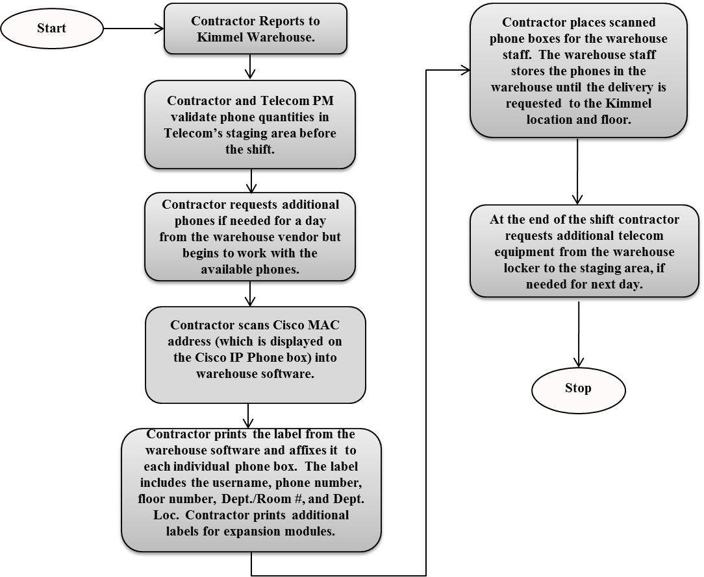

Task 2: Moving Cisco Phone Equipment from the Kimmel Pavilion Warehouse
- SUPPLIER will work with warehouse staff to coordinate the Cisco phone equipment move from the Kimmel Pavilion Warehouse to the Kimmel Pavilion for each deployment phase.
- Contractor will work with the NYUHC project team and the warehouse vendor to schedule each equipment move by the warehouse vendor to the appropriate Kimmel location.

Task 3: Audit, Install and Test Cisco Phone Equipment and Accessories
- SUPPLIER will work with the NYUHC Telecom Project Manager to confirm /audit Cisco phone equipment received for each specific deployment phase. SUPPLIER will request additional telephones from the warehouse, if needed.
- SUPPLIER will be responsible for assembling and installing all Cisco equipment and associated accessories (expansion modules) in designated locations.
- HOSPITALS has provided PowerPoint slides showing the telephone, expansion module, and foot-stand installation instructions. This PowerPoint file has been provided to SUPPLIERS as part of the scope of work documents issued.
- SUPPLIER will be responsible for neatly consolidating all packing materials/waste (phone cardboard boxes, etc.) DAILY for subsequent collection and disposal by the Warehouse team.

Task 4: Install NYU Required Standard Stickers and Place Desk Drops
- SUPPLIER will be provided with NYUHC’s standard emergency call red stickers to install on all Cisco phones in the exact location indicated in the telephone picture below.
- SUPPLIER will also neatly distribute all defined desk drops, i.e. coded cards and laminated quick tips user guides) to be placed under each phone.

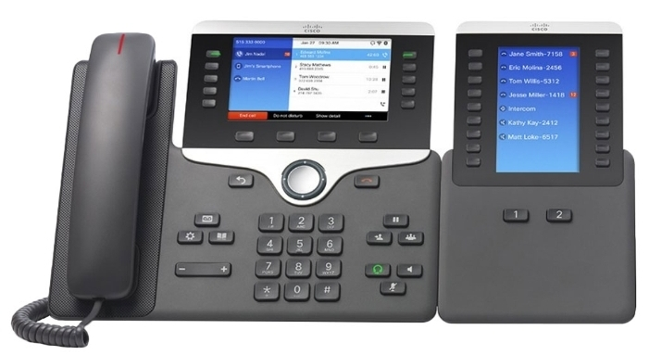
For Emergency, please Call 33-911

Task 5: Testing Devices and Logging Issues
- SUPPLIER will be responsible for conducting testing on all Cisco phones and analog devices using multiple teams. It is expected that testing will require approximately 5 minutes per phone. Please refer to testing process below.
- SUPPLIER will leave a blue 15 foot CAT 6E patch cord plugged into each telephone and ensure that it is clearly visible for NYUHC Desktop Support team members. Desktop Support will subsequently neatly dress cable runs.
- SUPPLIER will be responsible for submitting daily progress status reports, logging issues on a daily basis, and reporting them to the designated NYUHC Project Manager.

Test Plan:
- Install Phone at the Desk Top
- Plug Ethernet cord into the wall jack
- Cisco registers to the Call Manager
- Confirm (Direct Inward Dial) number
- Pick up handset to confirm dial tone
- Place a test call to 212-555-1212
- Proceed to the next station

Cisco IP Telephone Deployment Process

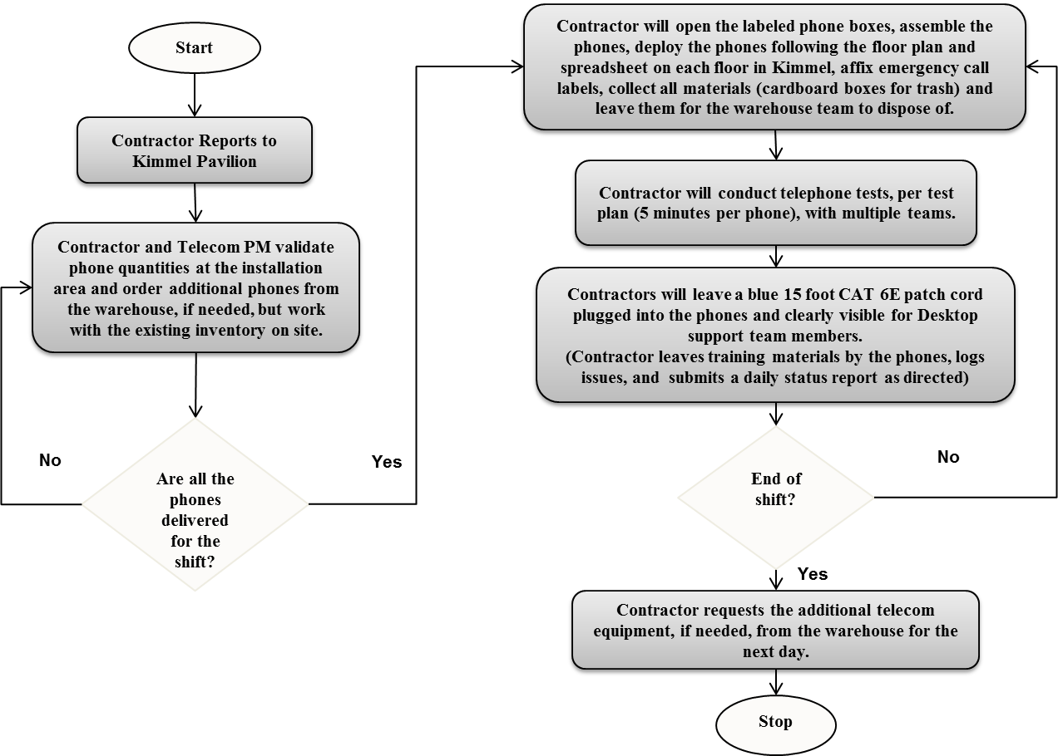

Just-In-Time Telephone Staging and Deployment Assistance

It is possible that NYUHC will require what we are describing as "Just-In-Time" telephone staging and deployment assistance. Such work would be outside of the five (5) phases of work defined in the scope of work provided above. For a "Just-In-Time event, NYUHC would provide the SUPPLIER with only one (1) week advance notice of such required assistance and the SUPPLIER would be required to perform the exact same telephone staging, deployment, and testing tasks as defined in the scope of work defined above. In the appropriate worksheet within the provided Kimmel Phone Deployment Pricing Workbook, SUPPLIER must provide their pricing quotation for Small (1-25 telephones), Medium (26 to 75 telephones), and Large (76 to 150 telephones) "Just-In-Time" assistance.

Add/Alternate Scope of Work - Science Building

NYUHC also has another large construction project underway for its new Science Building on the main campus. The clinical researchers and scientists that will occupy this new facility will be moving in over an estimated period of 6 months starting around November 2017.

NYUHC Telecommunications Department resources will carry out most of the Cisco IP telephone deployment for this facility. It is possible though that due to the resource requirements of multiple other ongoing projects, it may be necessary to utilize the services of the SUPPLIER selected through this Kimmel Telephone Deployment RFP. If such services are required for a specific group of Science Building staff, the SUPPLIER would be provided with 2 weeks’ notice to provide the necessary resources to neatly deploy and test the required quantity of phones. Phones can be deployed during normal business hours.

The phones will previously have been built in Cisco CallManager by NYUHC Telecommunications resources. The phone boxes would also already have been scanned and labeled with the appropriate floor location and extension. There will be no warehouse work for the SUPPLIER as part of the potential Science Building deployment assistance. The tasks are as follows:

- SUPPLIER will have to coordinate with NYUHC telecom team to gather phones from a staging area (presently unknown.)
- SUPPLIER staff will cart, ship, move pallet of materials to the science building job site/floor.
- SUPPLIER will assemble phones and place the phones following the NYUHC instructions on the marked up floor plans and job sheet.
- SUPPLIER will test phones following the test instructions from the NYUHC telecom team (test phones and test lines will be provided.)
- SUPPLIER will disassemble boxes to a flat state, gather bubble wrap, packing peanuts, paper materials and place in Hefty bags and trash bins provided. Deployment and staging area must be spotless.
- SUPPLIER will report back to the NYUHC telecom project team to provide frequent updates and status.

NYUHC needs the SUPPLIER responding to this RFP to also provide pricing for such potential telephone deployment and testing services for quantities of 10, 25 and 50 telephones at a time. Pricing for these potential a la carte services is to be provided on the Science Building Deploy Costs worksheet within the Kimmel Telephone Staging and Deployment Pricing Workbook. A separate purchase order will be created for the the additional work.

Professional Services and Customer Support

All questions below need to be answered within this RFP document.

13.1 Describe your professional services practice.

13.2 Briefly describe your experience in implementing similar solutions. Clearly describe the experience of the specific proposed project team members in successfully installing and testing Cisco 8800 series IP telephones. Indicate how you provided support to the company to implement such solutions and outline any road blocks you encountered and how they were resolved. Highlight company strengths related to this scope of work requested by NYUHC.

13.3 What specific personnel will be involved in delivering the requested services both directly and indirectly? Provide information regarding the experience and expertise of the specific proposed resources. Please provide proposed team, experience of proposed team and single point of contact who will manage the entire project. If SUPPLIER proposes to use any subcontracted resources for any part of the scope of work requested within this RFP, SUPPLIER must clearly define what subcontractors would be used and for what specific tasks. SUPPLIER must also provide company information regarding any proposed subcontractors as well as information regarding their successful performance on similar projects.

13.4 Identify the key manager within your organization who is ultimately responsible for ensuring the success of this implementation.

13.5 Describe your proposed staging and implementation methodologies, including:

- Specific activities to be conducted
- Describe your proposed telephone deployment process
- Provide a detailed management plan and outline of the proposed workflow and any requirements to deliver services
- Define any required NYUHC team members necessary to ensure a comprehensive, successful deployment and the tasks SUPPLIER expects the NYUHC resources to perform.
- What types of standard or ad hoc reports do you provide detailing project status?
- What service guarantees do you offer?

Pricing

SUPPLIERS must use only the provided Kimmel Telephone Staging and Deployment Pricing Workbook to provide their pricing information.

Description of Company

All questions need to be answered within this RFP document.

The SUPPLIER must have provided Cisco IP Telephony staging and deployment services and solutions for a minimum of three (3) years. Please define the duration and extent of your experience and capabilities in this regard.

Please provide:
- The company’s full name, address, main telephone number, and appropriate contact information, including e-mail address.
- A brief historical perspective on your company (years in the business, growth via mergers and acquisitions, key industry innovations)
- What are your company values?
- Describe your corporate culture. Explain how you differentiate yourself from your competition.
- Describe the full range of services your company offers and the corresponding rates. Include all services that will be available and all expenses that we would incur under this agreement.
- List office locations and specific responsibilities of each area.
- Please provide an overview of your company’s growth over the past five years.
- What percentage of your business is in healthcare?

Past Performance and References

Provide at least three (3) references of past deployments in a healthcare setting of similar size and scope of NYUHC.

For each reference, please include the following:
- Healthcare organization name, contact name, title, address and telephone number.
- Describe the relationship and services provided.
- If you cannot provide at least one healthcare reference of a similar size and scope of NYUHC, please explain and indicate the largest installation you have performed.
- Provide current and past account information, of similar size and configuration. Include:
- A current, long-term customer
- A current customer implemented in the past 18 months

Failure to provide suitable references to NYUHC will result in the SUPPLIER’s bid being rejected without further consideration.

Contract Terms and Master Services Agreement (MSA)

NYUHC expects this project to be governed in accordance with its contracting standards as per the attached Master Services Agreement (MSA). By responding to this RFP, SUPPLIER agrees that the terms of the attached MSA will be applicable to govern all proposals and transactions unless, as part of the SUPPLIER’s RFP response, the attached MSA is counter-proposed by responsive redline.

Evaluation Criteria

NYUHC plans to evaluate the supplier’s response based on the following criteria:

- Experience of Organization in Performing Similar Installation
- Experience of Key Personnel
- Price Competetiveness
- Adherence to NYUHC Terms and Conditions
- Product and Customer Support
- Reference

Attachments

Exhibit A: Pricing Sheet
Exhibit B: Installation Process for Cisco 8800
Exhibit C: Master Service Agreement

